

GROUP ASSIGNMENT
(GROUP WORK)

CT043-3-1-IN

INTRODUCTION TO NETWORKING

APD1F2307CS(CYB)_APU1F2307CS(CYB)

HAND OUT DATE : 01 AUGUST 2023

HAND IN DATE : 20 OCTOBER 2023

LECTURER NAME : MR. SHAHAB ALIZADEH

WEIGHTAGE : 50%

INSTRUCTIONS TO CANDIDATES:

1 Assignment is to be submitted through online submission (Moodle).

2 Students are advised to underpin their answers with the use of references (cited using the APA Name System of Referencing).

3 Late submission will be awarded zero (0) unless Extenuating Circumstances (EC) are uphelp.

4 Caes of plagiarism will be penalized.

5 You must obtain 50% overall to pass this module.

WORK BREAKDOWN STRUCTURE (WBS)

Student Name:  TP Number: | VISHVAN RAJ A/L RAJASEKER  (TP070829) | MARWAN WALID FOUAD ZAKARIA HASSAN  (TP072632) | WONG MING SOON  (TP07077) | LEE JUN XIAN JAKE  (TP073971)
Group Component
Creativity for network design | ü | ü | ü | ü
Technical concepts for configuration | ü | ü | ü | ü
Q & A | ü | ü | ü | ü
Communication Skills | ü | ü | ü | ü
Total Group Component Contribution Percentage (%) | 40% | 40% | 40% | 40%
Individual Component
Network Topology Design | ü | ü | ü | ü
Topology Justification | ü | ü | ü | ü
IP Addressing Plan & Justification | ü | ü | ü | ü
Justification of the configuration techniques | ü | ü | ü | ü
Referencing | ü | ü | ü | ü
Documentation | ü | ü | ü | ü
Total Individual Component Contribution Percentage (%) | 60% | 60% | 60% | 60%
Signature: |  |  |  | 

Table of Contents
WORK BREAKDOWN STRUCTURE (WBS) 3
1.0 STUDENT 1: MARWAN WALID FOUAD ZAKARIA HASSAN TP072632 (KL Branch) 6
1.1 LOGICAL TOPOLOGY DESIGN 6
1.1.1 NETWORK TOPOLOGY DESIGN 6
1.2 JUSTIFICATION OF THE TOPOLOGY 11
1.2.1 STAR TOPOLOGY 11
1.3 IP ADDRESING SCHEME 13
1.3.1 IP ADDRESSING TABLE 13
1.3.2 JUSTIFICATIONS OF THE IP ADDRESSING AND SUBNETTING SCHEME 17
2.0 STUDENT 2: WONG MING SOON TP070778 (Penang Branch) 18
2.1 LOGICAL TOPOLOGY DESIGN 18
2.2 JUSTIFICATION OF THE TOPOLOGY 23
2.2.1 STAR TOPOLOGY 23
2.3 IP ADDRESING SCHEME 24
2.3.1 IP ADDRESING TABLE 24
2.3.2 JUSTIFICATIONS OF THE IP ADDRESSING AND SUBNETTING SCHEME 26
3.0 STUDENT 3: LEE JUN XIAN JAKE TP073971 (Ipoh Branch) 27
3.1 LOGICAL TOPOLOGY DESIGN 27
3.2 JUSTIFICATION OF THE TOPOLOGY 32
3.3 IP ADDRESING SCHEME 34
4.0 STUDENT 4: VISHVAN RAJ A/L RAJASEKER TP070829 (Malacca Branch) 37
4.1 LOGICAL TOPOLOGY DESIGN 37
4.1.1 NETWORK TOPOLOGY DESIGN 37
4.2 JUSTIFICATION OF THE TOPOLOGY 42
4.2.1 STAR TOPOLOGY AND EXTENDED STAR TOPLOGY 42
4.3 IP ADDRESING SCHEME 44
4.3.1 IP ADDRESSING TABLE 44
4.3.2 JUSTIFICATIONS OF THE IP ADDRESSING AND SUBNETTING SCHEME 48
5.0 JUSTIFICATION OF THE CONFIGURATION TECHNIQUES 49
5.1 CONFIGURATION FOR ROUTER AND SWTICHES 49
5.2 IP ROUTING (RIP) 50
5.2 STATIC CONFIGURATION FOR END DEVICES AND IOT DEVICES 51
6.0 CONCLUSION 53
7.0 REFERENCES 54

1.0 STUDENT 1: MARWAN WALID FOUAD ZAKARIA HASSAN TP072632 (KL Branch)

1.1 LOGICAL TOPOLOGY DESIGN

1.1.1 NETWORK TOPOLOGY DESIGN

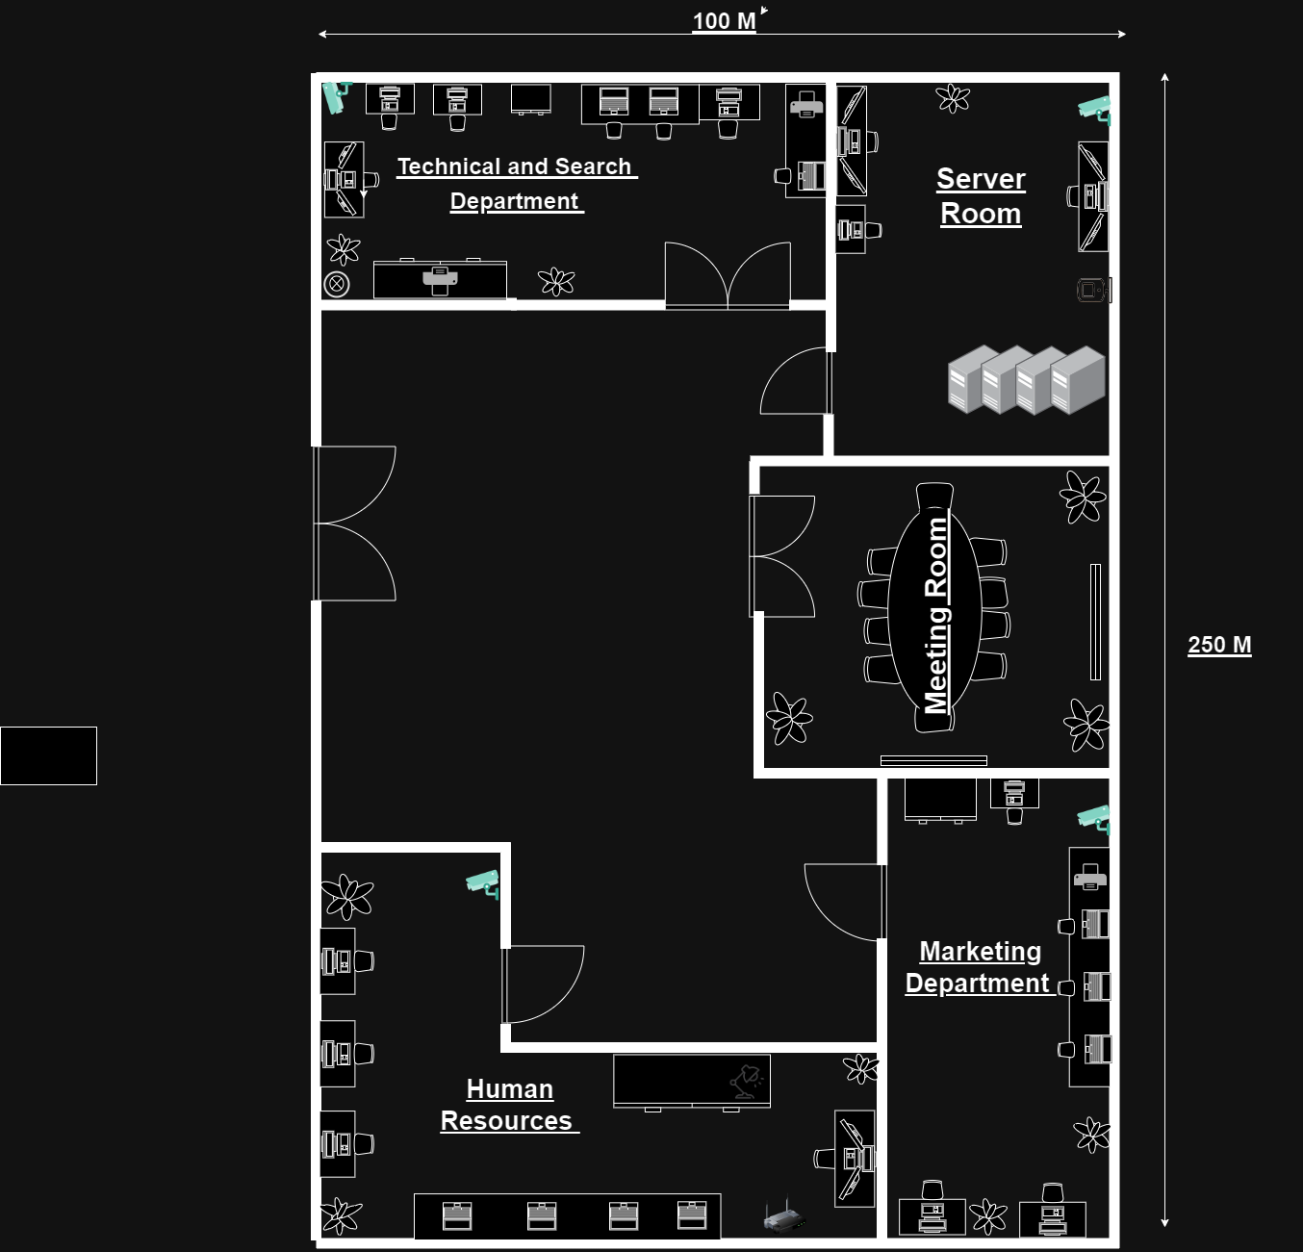Figure 1.1 KL Floor Plan
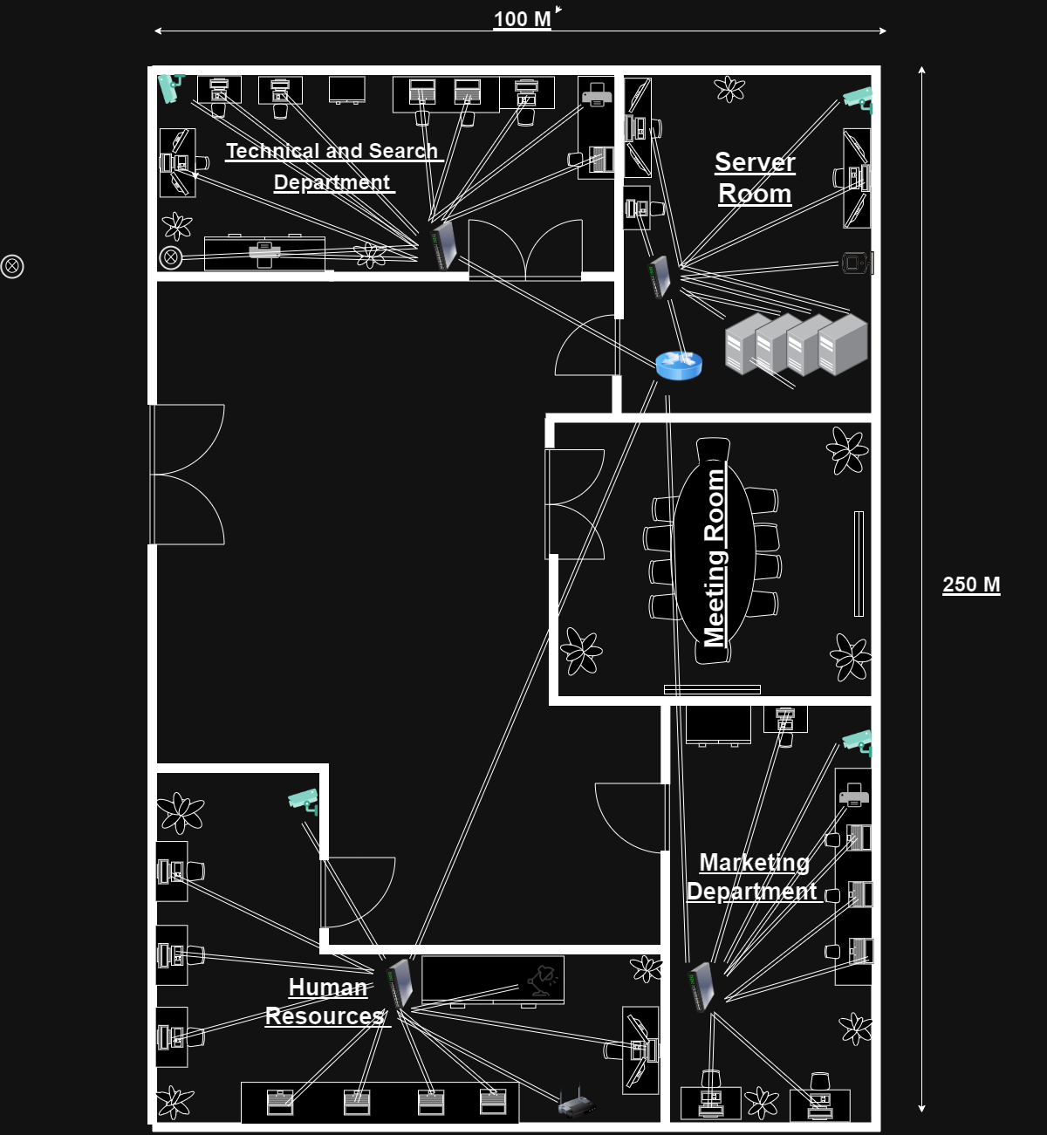Figure 1.2 KL Network Diagram

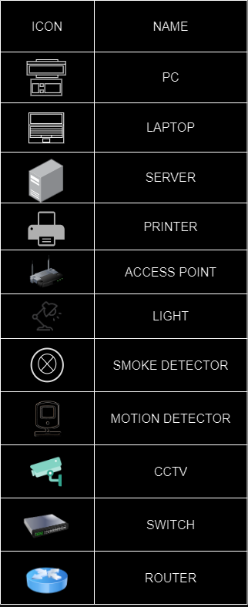
MapleTech is a leading technology company with its headquarters in Kuala Lumpur, Malaysia. The company operates with four departments: Marketing, Human Resources, Technical and Search and Server. These departments together contribute to the company's success.
The Marketing Department takes charge of designing and implementing marketing campaigns aimed at raising awareness about MapleTechs products and services while convincing customers to make purchases. They also manage the company's brand identity across all communication channels, ensuring consistency and promoting its image.
The Human Resources Department is responsible for finding talents for MapleTech through recruitment efforts. They also focus on training their employees to ensure they have the skills and knowledge for their roles within the company. Moreover, they actively contribute to enhancing the work atmosphere by promoting positive thinking among their employees.
The Technical and Search Department is dedicated to developing and maintaining MapleTechs infrastructure while attempting to also improve the company's search engine rankings. They ensure that all online platforms are functioning effectively so that customers can easily locate MapleTech online.
Finally, the Server Department handles responsibilities related to securing and maintaining MapleTechs servers along, with its network systems.Their main responsibility is to ensure the operation of the company's systems and securing its data from any leakages .
The MapleTech branch, in Kuala Lumpur is the largest among all the companys branches measuring 250 meters long and 100 meters wide. Kuala Lumpur, being a hub for finance and economics, hosts a pool of highly skilled professionals. MapleTech strategically chose this location to take advantage of these benefits.
This branch offers the opportunity for each department to function efficiently with room for growth. Equipped with great technology and services, the office creates a productive work environment for its employees to ensure the success of the company.

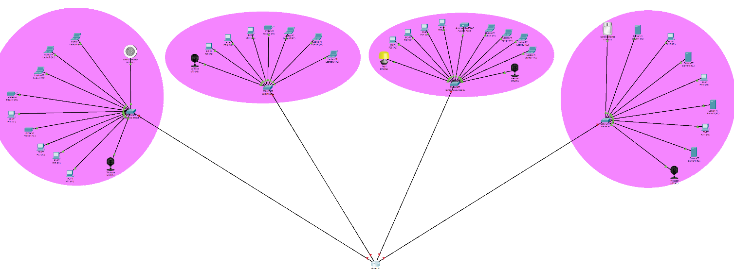Figure 1.3 KL Branch Network topology design
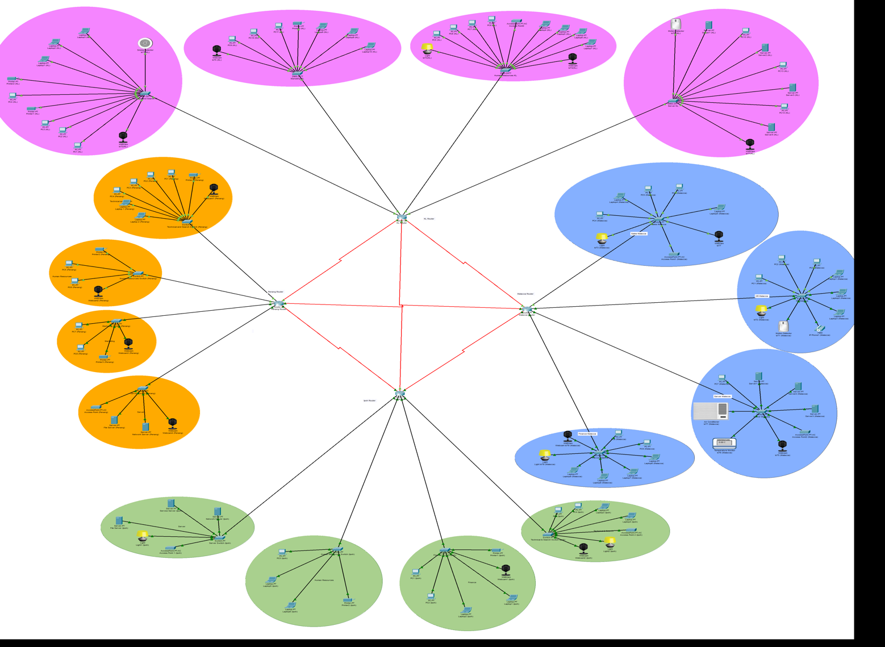 Figure 1.4 Network Topology for all 4 branches

Cisco Packet Tracer serves as a network simulator enabling users to construct and simulate network configurations. It proves to be a tool for both networking students and professionals allowing them to explore network designs and troubleshoot issues within a secure environment.
In the case of the MapleTech Kuala Lumpur branch office I used Cisco Packet Tracer to establish a network layout using the four departments: Marketing, Human Resources, Technical and Search well as the Server Department. Each department is equipped with its router connected through switches known as Switch PT and the router belongs to the PT Router category.
Within this network topology various end devices such as PCs, laptops, servers, printers, and access points are included. Additionally, I used Internet of Things (IoT) devices like lights smoke detectors motion detectors along with webcams.
By creating a network topology in Cisco Packet Tracer, I was able to recreate real-world scenarios effectively while ensuring that the simulated traffic network could be managed. This aspect holds significance in ensuring both reliability and efficiency for the system.

1.2 JUSTIFICATION OF THE TOPOLOGY

1.2.1 STAR TOPOLOGY

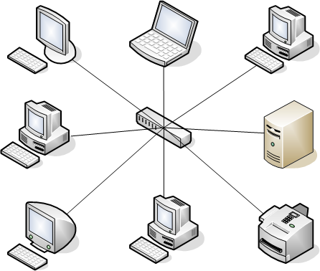 Figure 1.5 Star Topology

Star topology is the best choice for the Kuala Lumpur branch of MapleTech. This option is preferred because it offers simplicity, reliability, scalability, good performance and cost effectiveness (Wevolver, 2023)
The star topology stands out as the network configuration to set up and manage. In this topology each device connects to a switch, which makes troubleshooting problems and adding or removing devices a piece of cake. Moreover, the reliability of the star topology shines through as any device failure does not impact the network or any other hosts (Javatpoint, 2023). Additionally, when it comes to scaling up their network in the future MapleTech can easily expand it by adjusting new devices on the network.
Furthermore, for networks including big or medium sized businesses, like MapleTechs operation this configuration delivers good performance. If necessary though performance can be further enhanced by employing higher quality switches and cables. Lastly implementing a star topology proves less expensive compared to any alternative’s topologies.

1.3 IP ADDRESING SCHEME

1.3.1 IP ADDRESSING TABLE

Device | Interface | Network Address | IP Address | Usable Address Range | Broadcast Address | Default Gateway
Router KL | Fa0/0 | 192.168.40.0 | 192.168.40.1 | 192.168.40.1 - 192.168.40.14 | 192.168.40.15 | N/A
 | Fa2/0 | 192.168.40.16 | 192.168.40.17 | 192.168.40.17 - 192.168.40.31 | 192.168.40.32 | N/A
 | Fa1/0 | 192.168.40.32 | 192.168.40.33 | 192.168.40.33 - 192.168.40.47 | 192.168.40.48 | N/A
 | Fa3/0 | 192.168.40.48 | 192.168.40.49 | 192.168.40.49 - 192.168.40.62 | 192.168.40.63 | N/A
 | Se6/0 | 192.168.40.208 | 192.168.40.209 | 192.168.40.209 - 192.168.40.211 | 192.168.40.212 | N/A
 | Se7/0 | 192.168.40.236 | 192.168.40.237 | 192.168.40.237 - 192.168.40.239 | 192.168.40.240 | N/A
 | Se8/0 | 192.168.40.232 | 192.168.40.233 | 192.168.40.233 - 192.168.40.235 | 192.168.40.236 | N/A
Technical and Search Switch | Fa0/12 | 192.168.40.0 | 192.168.40.2 | N/A | N/A | 192.168.40.1
Human Resources Switch | Fa0/12 | 192.168.40.16 | 192.168.40.18 | N/A | N/A | 192.168.40.17
Marketing Switch | Fa0/9 | 192.168.40.32 | 192.168.40.34 | N/A | N/A | 192.168.40.33
Server Switch | Fa0/10 | 192.168.40.48 | 192.168.40.50 | N/A | N/A | 192.168.40.49
PC1 (KL) |  | 192.168.40.0 | 192.168.40.3 | N/A | N/A | 192.168.40.1
PC2 (KL) |  | 192.168.40.0 | 192.168.40.4 | N/A | N/A | 192.168.40.1
PC3 (KL) |  | 192.168.40.0 | 192.168.40.5 | N/A | N/A | 192.168.40.1
Printer1 (KL) |  | 192.168.40.0 | 192.168.40.6 | N/A | N/A | 192.168.40.1
PC4 (KL) |  | 192.168.40.0 | 192.168.40.7 | N/A | N/A | 192.168.40.1
Printer2 (KL) |  | 192.168.40.0 | 192.168.40.8 | N/A | N/A | 192.168.40.1
Laptop1 (KL) |  | 192.168.40.0 | 192.168.40.9 | N/A | N/A | 192.168.40.1
Laptop2 (KL) |  | 192.168.40.0 | 192.168.40.10 | N/A | N/A | 192.168.40.1
Laptop3 (KL) |  | 192.168.40.0 | 192.168.40.11 | N/A | N/A | 192.168.40.1
Smoke Detector IoT1 (KL) |  | 192.168.40.0 | 192.168.40.12 | N/A | N/A | 192.168.40.1
Webcam IoT2 (KL) |  | 192.168.40.0 | 192.168.40.13 | N/A | N/A | 192.168.40.1
Light IoT3 (KL) |  | 192.168.40.16 | 192.168.40.18 | N/A | N/A | 192.168.40.17
PC5 (KL) |  | 192.168.40.16 | 192.168.40.20 | N/A | N/A | 192.168.40.17
PC6 (KL) |  | 192.168.40.16 | 192.168.40.21 | N/A | N/A | 192.168.40.17
PC7 (KL) |  | 192.168.40.16 | 192.168.40.22 | N/A | N/A | 192.168.40.17
PC8 (KL) |  | 192.168.40.16 | 192.168.40.23 | N/A | N/A | 192.168.40.17
Laptop4 (KL) |  | 192.168.40.16 | 192.168.40.24 | N/A | N/A | 192.168.40.17
Laptop5 (KL) |  | 192.168.40.16 | 192.168.40.25 | N/A | N/A | 192.168.40.17
Laptop6 (KL) |  | 192.168.40.16 | 192.168.40.26 | N/A | N/A | 192.168.40.17
Laptop7 (KL) |  | 192.168.40.16 | 192.168.40.27 | N/A | N/A | 192.168.40.17
Webcam IoT4 (KL) |  | 192.168.40.16 | 192.168.40.28 | N/A | N/A | 192.168.40.17
Webcam IoT5 (KL) |  | 192.168.40.32 | 192.168.40.35 | N/A | N/A | 192.168.40.33
PC9 (KL) |  | 192.168.40.32 | 192.168.40.36 | N/A | N/A | 192.168.40.33
PC10 (KL) |  | 192.168.40.32 | 192.168.40.37 | N/A | N/A | 192.168.40.33
PC11 (KL) |  | 192.168.40.32 | 192.168.40.38 | N/A | N/A | 192.168.40.33
Printer3 (KL) |  | 192.168.40.32 | 192.168.40.39 | N/A | N/A | 192.168.40.33
Laptop8 (KL) |  | 192.168.40.32 | 192.168.40.41 | N/A | N/A | 192.168.40.33
Laptop9 (KL) |  | 192.168.40.32 | 192.168.40.42 | N/A | N/A | 192.168.40.33
Laptop10 (KL) |  | 192.168.40.32 | 192.168.40.43 | N/A | N/A | 192.168.40.33
Motion Detector IoT6 (KL) |  | 192.168.40.48 | 192.168.40.52 | N/A | N/A | 192.168.40.49
Server1 (KL) |  | 192.168.40.48 | 192.168.40.53 | N/A | N/A | 192.168.40.49
PC12 (KL) |  | 192.168.40.48 | 192.168.40.54 | N/A | N/A | 192.168.40.49
Server2 (KL) |  | 192.168.40.48 | 192.168.40.55 | N/A | N/A | 192.168.40.49
PC13 (KL) |  | 192.168.40.48 | 192.168.40.56 | N/A | N/A | 192.168.40.49
Server3 (KL) |  | 192.168.40.48 | 192.168.40.57 | N/A | N/A | 192.168.40.49
PC14 (KL) |  | 192.168.40.48 | 192.168.40.58 | N/A | N/A | 192.168.40.49
Server4 (KL) |  | 192.168.40.48 | 192.168.40.59 | N/A | N/A | 192.168.40.49
Webcam IoT7(KL) |  | 192.168.40.48 | 192.168.40.61 | N/A | N/A | 192.168.40.49

1.3.2 JUSTIFICATIONS OF THE IP ADDRESSING AND SUBNETTING SCHEME

MapleTechs Kuala Lumpur branch has chosen to adopt a Class C IP address, 192.168.40.0 as the foundation, for its network infrastructure. This address range provides space to meet both future network needs of the company. The initial IP address assigned to the branch is 192.168.40.1 with the last utilized IP address being 192.168.40.236. This ensures that MapleTech Kuala Lumpur can easily accommodate devices and expand its network as required by business growth.
To effectively allocate IP addresses for each department varying its network requirements, the network has been divided into four subnets: Marketing, Human Resources, Technical and Search and Server departments. Variable Length Subnet Masking (VLSM) was employed in creating subnets of sizes to ensure that each department has IP addresses for both present and future needs.
Using a /28 prefix length allowed for the creation of 16 subnets each providing up to 14 IP addresses for their department’s usage requirements. This approach showcases MapleTechs dedication towards resource management and long-term planning of their network.
With this design in place and a significant pool of IP addresses, MapleTech Kuala Lumpur is well equipped to scale their network infrastructure effortlessly in support of expanding operations and any future expansions that they may undertake.

2.0 STUDENT 2: WONG MING SOON TP070778 (Penang Branch)

2.1 LOGICAL TOPOLOGY DESIGN

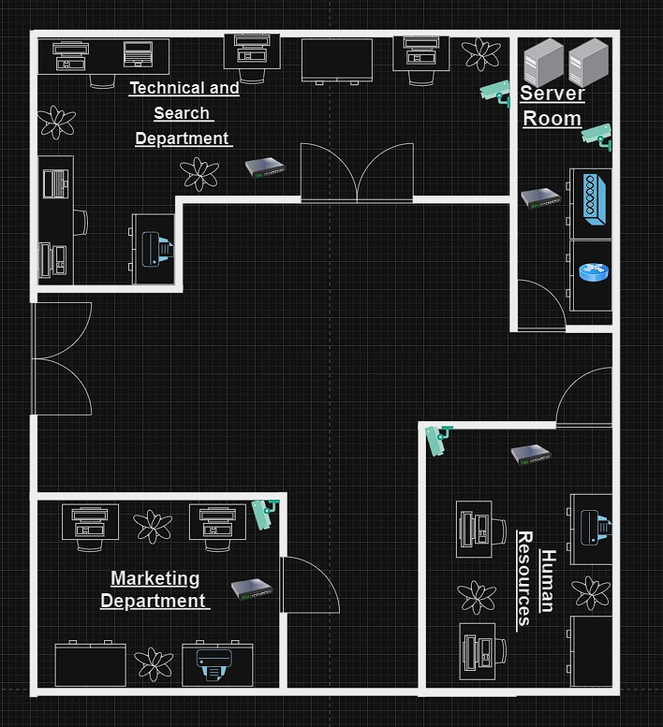

Figure 2.1 Penang Floor Plan

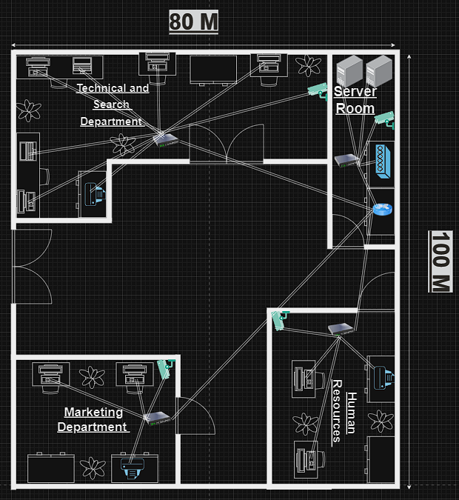

Figure 2.2 Network Diagram for Penang

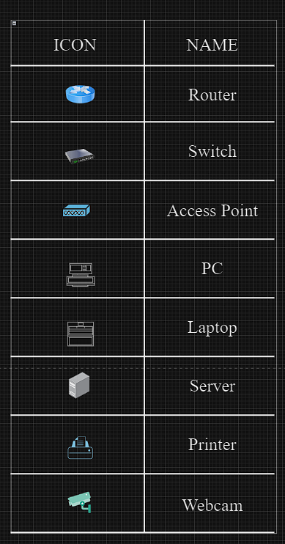
Figure 2.3 Table of the Icons
The floor plan for MapleTech branch in Penang is equipped with 4 departments which are the Technical and Search department, Server room, Marketing Department and Human Department. The technical and Search department is to manage the company’s search engine and related search technologies to ensure users can easily find the information they need. This department also provides technical support to solve technical problems inside and outside the company. The server room is to provide security measures to protect server rooms from unauthorised access and data breach threats. The server room can also monitor server performance and network traffic and maintain the proper hardware and software operation. The marketing department develops marketing strategies to promote the company’s products and services and attract potential customers. This department also conducts market research and analysis to understand target audience needs and competitor dynamics. The human resources department is to manage employee recruitment, training and development to ensure the company has a team of highly qualified employees. This department also ensures the company complies with laws and regulations, including labour and employment law regulations.

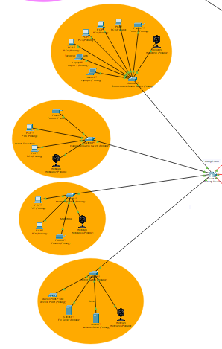
Figure 2.4 Network Topology of Penang Branch

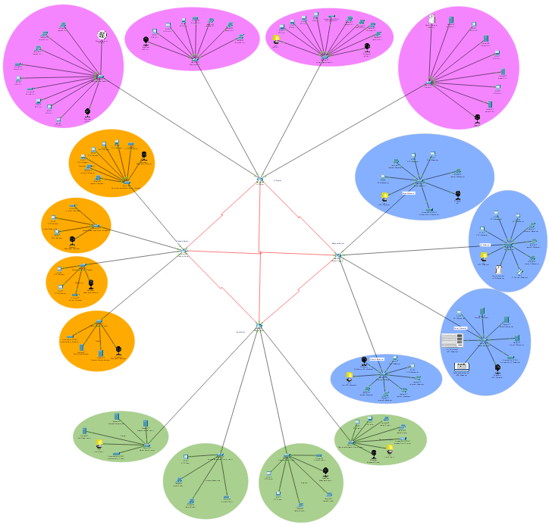
Figure 2.5 Network Topology of all branch
To create a network topology, the Cisco Packet Tracer is a good tool that allows users to design and simulate new network topologies, enabling users to test various configuration options and ensure network stability and performance without physically deploying hardware equipment. The departments of the Penang branch in the orange area are created based on the Penang floor plan above. One router for the Penang branch will connect to every department. Each department is also equipped with one switch, which is Switch PT, that connects to the router, which is Router PT. This network topology has some end devices, such as computers, laptops, printers, webcams, servers and access points. The Penang branch has 20 hosts: 8 for the Technical and Search department and four for three departments: the Human Resources department, Marketing department and Server room.

2.2 JUSTIFICATION OF THE TOPOLOGY

2.2.1 STAR TOPOLOGY

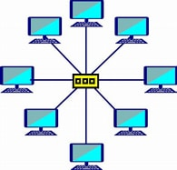
Figure 2.6 STAR TOPOLOGY
Star topology is a computer network topology in which all devices are connected to a central node. A star topology is also known as spoke–hub distribution paradigm in computer networks.

Advantages of Star network
- Centralized Control
- Scalability
- High Performance
- Easy Troubleshooting
- Security
- Cable Management
According to the information, star topology is more suitable and helpful for the Penang Branch of MapleTech.

2.3 IP ADDRESING SCHEME

2.3.1 IP ADDRESING TABLE

Device | Interface | Network Address | IP Address | Usable Address Range | Broadcast Address | Default Gateway
Router Penang | Fa0/0 | 192.168.40.176 | 192.168.40.177 | 192.168.40.177 - 192.168.40.190 | 192.168.40.191 | N/A
 | Fa1/0 | 192.168.40.192 | 192.168.40.193 | 192.168.40.193 - 192.168.40.198 | 192.168.40.199 | N/A
 | Fa2/0 | 192.168.40.200 | 192.168.40.201 | 192.168.40.201 - 192.168.40.206 | 192.168.40.207 | N/A
 | Fa3/0 | 192.168.40.224 | 192.168.40.225 | 192.168.40.225 - 192.168.40.230 | 192.168.40.231 | N/A
 | Se6/0 | 192.168.40.220 | 192.168.40.222 | 192.168.40.222 - 192.168.40.224 | 192.168.40.224 | N/A
 | Se7/0 | 192.168.40.212 | 192.168.40.214 | 192.168.40.214 - 192.168.40.216 | 192.168.40.216 | N/A
Technical and Search Switch | Fa0/1 | 192.168.40.176 | 192.168.40.178 | N/A | N/A | 192.168.40.177
Human Resources Switch | Fa0/1 | 192.168.40.192 | 192.168.40.194 | N/A | N/A | 192.168.40.193
Marketing Switch | Fa0/1 | 192.168.40.200 | 192.168.40.202 | N/A | N/A | 192.168.40.201
Server Switch | Fa0/1 | 192.168.40.224 | 192.168.40.226 | N/A | N/A | 192.168.40.225

Device | Interface | Network Address | IP Address | Usable Address Range | Broadcast Address | Default Gateway
PC1 (Penang) |  | 192.168.40.176 | 192.168.40.179 | N/A | N/A | 192.168.40.177
PC2 (Penang) |  | 192.168.40.176 | 192.168.40.180 | N/A | N/A | 192.168.40.177
PC3 (Penang) |  | 192.168.40.176 | 192.168.40.181 | N/A | N/A | 192.168.40.177
PC4 (Penang) |  | 192.168.40.176 | 192.168.40.182 | N/A | N/A | 192.168.40.177
Printer1 (Penang) |  | 192.168.40.176 | 192.168.40.183 | N/A | N/A | 192.168.40.177
Laptop 1 (Penang) |  | 192.168.40.176 | 192.168.40.184 | N/A | N/A | 192.168.40.177
Laptop 2 (Penang) |  | 192.168.40.176 | 192.168.40.185 | N/A | N/A | 192.168.40.177
Webcam1 (Penang) |  | 192.168.40.176 | 192.168.40.186 | N/A | N/A | 192.168.40.177
PC5 (Penang) |  | 192.168.40.192 | 192.168.40.195 | N/A | N/A | 192.168.40.193
PC6 (Penang) |  | 192.168.40.192 | 192.168.40.196 | N/A | N/A | 192.168.40.193
Printer2 (Penang) |  | 192.168.40.192 | 192.168.40.197 | N/A | N/A | 192.168.40.193
Webcam2 (Penang) |  | 192.168.40.192 | 192.168.40.198 | N/A | N/A | 192.168.40.193
PC7 (Penang) |  | 192.168.40.224 | 192.168.40.203 | N/A | N/A | 192.168.40.225
PC8 (Penang) |  | 192.168.40.224 | 192.168.40.204 | N/A | N/A | 192.168.40.225
Printer3 (Penang) |  | 192.168.40.224 | 192.168.40.205 | N/A | N/A | 192.168.40.225
Webcam3 (Penang) |  | 192.168.40.224 | 192.168.40.206 | N/A | N/A | 192.168.40.225
Access Point (Penang) |  | 192.168.40.200 | 192.168.40.227 | N/A | N/A | 192.168.40.201
File Server (Penang) |  | 192.168.40.200 | 192.168.40.228 | N/A | N/A | 192.168.40.201
Network Server (Penang) |  | 192.168.40.200 | 192.168.40.229 | N/A | N/A | 192.168.40.201
Webcam4 (Penang) |  | 192.168.40.200 | 192.168.40.230 | N/A | N/A | 192.168.40.201

2.3.2 JUSTIFICATIONS OF THE IP ADDRESSING AND SUBNETTING SCHEME

MapleTech Penang's decision to use Class C IP addresses (specifically 192.168.40.0) is consistent with the addressing scheme used by other MapleTech offices. For the Penang branch, the first IP address is 192.168.40.177, and the last IP address is 192.168.40.231. There are four departments using the network that have separate subnets which are the Technical and Search department, Server room, Marketing Department and Human Department. Variable Length Subnet Masking (VLSM) has been employed to create subnets of different sizes tailored to the specific requirements of each department, ensuring that each department receives an appropriate number of IP addresses for both their present. By using a /28 prefix length for the smaller subnets, MapleTech has demonstrated its commitment to future expansion. This allows each department to accommodate up to 14 devices, which is more than sufficient for current needs and provides room for growth without reconfiguration.

3.0 STUDENT 3: LEE JUN XIAN JAKE TP073971 (Ipoh Branch)

3.1 LOGICAL TOPOLOGY DESIGN

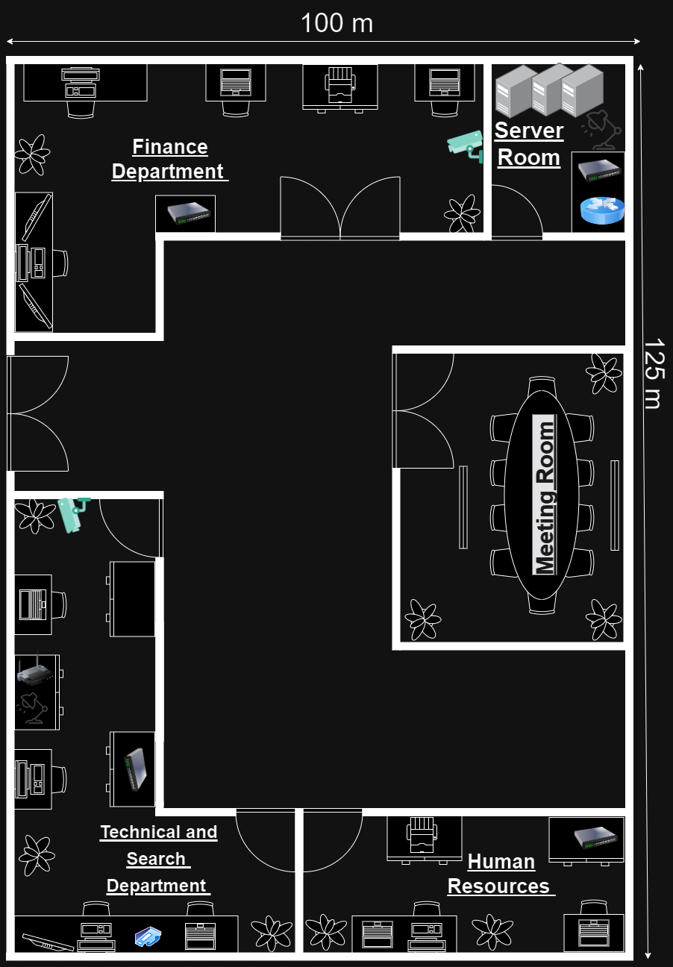
Figure 3.1 Ipoh Floor Plan

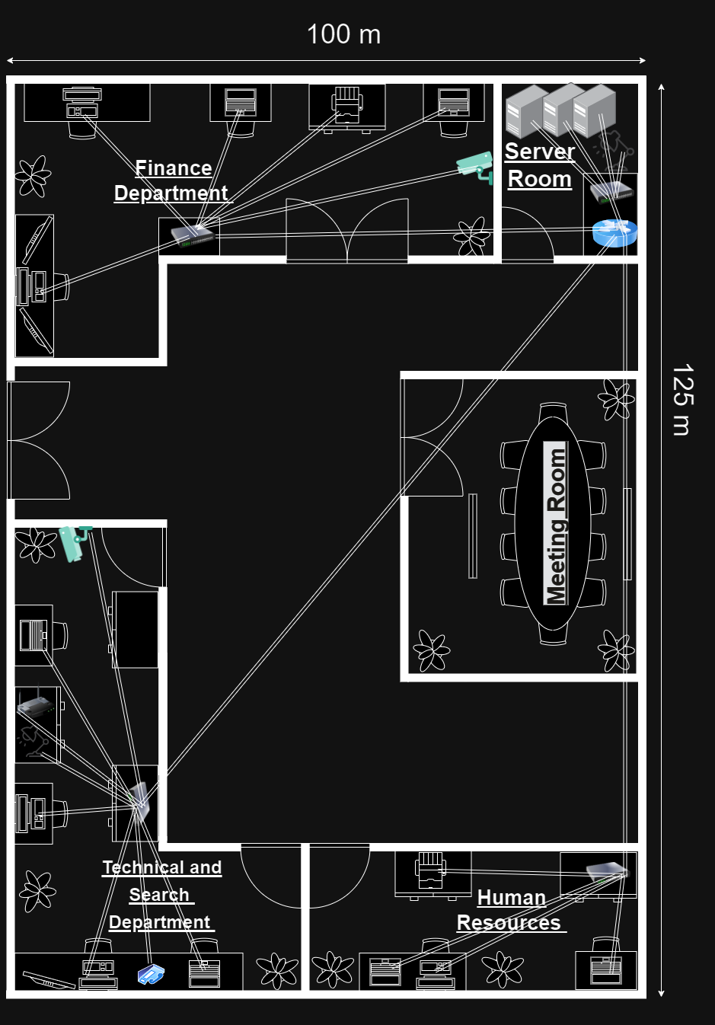
Figure 3.2 Ipoh Network Diagram

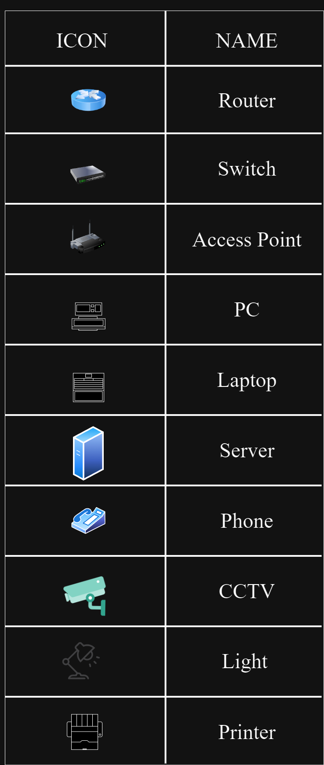
Figure 3.3 Table of the Icons

The floor plan of the Ipoh branch of MapleTech encompasses four departments: the Finance department, the Technical and Search department, the Human Resources department, and a server room. The length and width of the office are 125m and 100m, which is smaller than the Kuala Lumpur and Malacca branches but larger than the Ipoh branch. The Finance Department is responsible for tasks such as budget planning and cost control, among others. The Technical and Search Department is the technological core of the company, providing services such as networking, system maintenance, data management, application development, and more. The Human Resources Department oversees recruitment, training, and people management. The server room is an important department that ensures the security and stable operation of the network and systems. It also serves as the memory centre of the company.
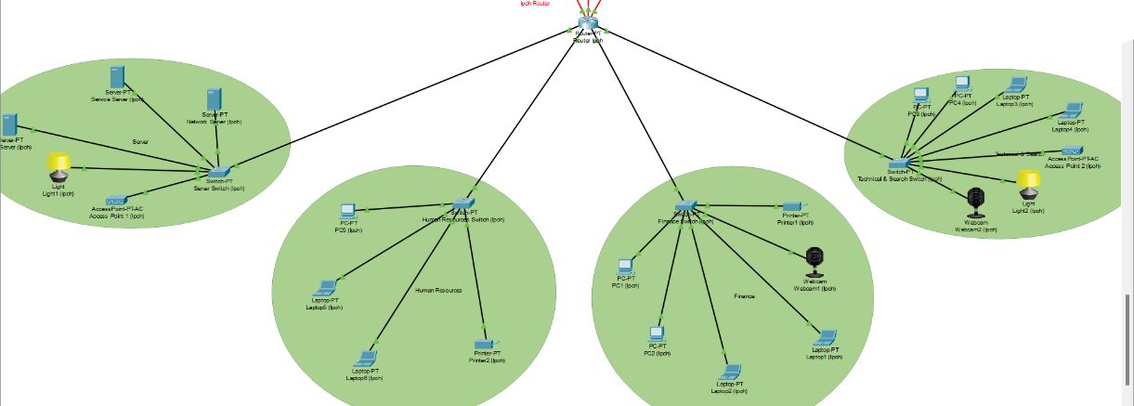
Figure 3.4 Network Topology of Ipoh branch

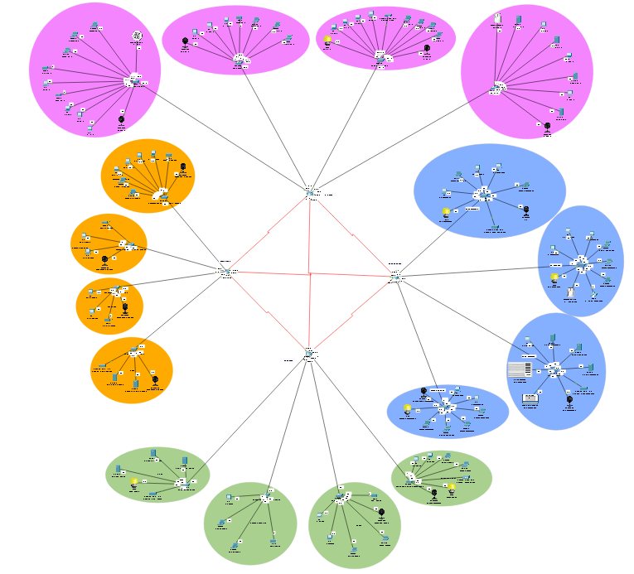
Figure 3.5 Network Topography of all 4 branches
This topology was created using Packet Tracer. The green domain represents the departments of the Ipoh branch, while the pink domain represents the departments of the Kuala Lumpur branch. The blue domain represents the departments of the Malacca branch, and the orange domain represents the departments of the Penang branch.
Each branch is connected by four routers, with a total of 6 cables connecting them. Each router uses 4 bits in the VLSM box. The Ipoh branch has 20 hosts: 4 hosts for the server room, the same amount for the Human Resources department, 6 hosts for the Finance department, and the same amount for the Technical and Search department. This utilizes 48 bits of the VLSM box based on its network structure.
The hosts at the Ipoh branch include 3 servers, 5 PCs, 6 laptops, and multiple IoT devices, such as lights and webcams. Each host is connected to a switch in their respective department, serving as the bridge between the hosts and the router. The switches and the routers are connected with gigabit ports to avoid any potential bottlenecks.

3.2 JUSTIFICATION OF THE TOPOLOGY

Star Topology
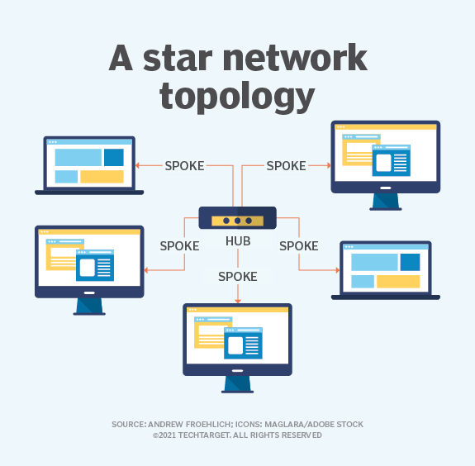
Figure 3.6 Star Network Topology

A star network is a local area network (LAN) topology in which all nodes -- personal computers (PCs), workstations or other devices -- are directly connected to a common central computer that is often referred to as a hub. Therefore, a star network is often referred to as a hub-and-spoke network topology. (Andrew Froehlich, 2021)
Advantages of Star Topology（pulkitagarwal03pulkit (account name), 2022)
- It is very reliable – if one cable or device fails then all the others will still work.
- It is high performing as no data collisions can occur.
- Less expensive because each device only needs one I/O port and wishes to relate to hub with one link.
- Easier to put in.
- Robust in nature
- Easy fault detection because the link is often easily identified.
- No disruptions to the network when connecting or removing devices.
- Each device requires just one port i.e., to attach to the hub.
- If N devices are connected to every other in star, then the number of cables required to attach them is N. So, it’s easy to line up.
According to this information, a star topology appears to be a suitable network topology for an office environment, including MapleTech. Particularly, for an organization experiencing frequent personnel changes, the flexibility of the star topology in adding or removing devices can be highly advantageous. Additionally, the star topology enhances data management, which is especially convenient for a medium-sized company like MapleTech.

3.3 IP ADDRESING SCHEME

Device | Interface | Network Address | IP Address | Usable Address Range | Broadcast Address | Default Gateway
Router Ipoh | Gig0/0 | 192.168.40.128 | 192.168.40.  129 | 192.168.40.129 - 192.168.40.142 | 192.168.40.143 | N/A
 | Gig1/0 | 192.168.40.144 | 192.168.40.  145 | 192.168.40.145 - 192.168.40.158 | 192.168.40.159 | N/A
 | Gig2/0 | 192.168.40.160 | 192.168.40.  161 | 192.168.40.161 - 192.168.40.166 | 192.168.40.167 | N/A
 | Gig3/0 | 192.168.40.168 | 192.168.40.  169 | 192.168.40.169 - 192.168.40.174 | 192.168.40.175 | N/A
 | Se4/0 | 192.168.40.232 | 192.168.40  .234 | 192.168.40.234 -192.168.40.236 | 192.168.40.237 | N/A
 | Se5/0 | 192.168.40.220 | 192.168.40.  221 | 192.168.40.221 -192.168.40.223 | 192.168.40.234 | N/A
 | Se6/0 | 192.168.40.216 | 192.168.40.  218 | 192.168.40.218 -192.168.40.220 | 192.168.40.220 | N/A
Finance Switch | Fa0/1 | 192.168.40.128 | 192.168.40.130 | N/A | N/A | 192.168.40.129
Technical and Search Switch | Fa0/1 | 192.168.40.144 | 192.168.40.146 | N/A | N/A | 192.168.40.145
Server Switch | Fa0/1 | 192.168.40.160 | 192.168.40.162 | N/A | N/A | 192.168.40.161
Human Resources Switch | Fa0/1 | 192.168.40.168 | 192.168.40.170 | N/A | N/A | 192.168.40.169
PC1  (Ipoh) |  | 192.168.40.128 | 192.168.40.131 | N/A | N/A | 192.168.40.129
PC2  (Ipoh) |  | 192.168.40.128 | 192.168.40.132 | N/A | N/A | 192.168.40.129
Laptop1  (Ipoh) |  | 192.168.40.128 | 192.168.40.133 | N/A | N/A | 192.168.40.129
Laptop2  (Ipoh) |  | 192.168.40.128 | 192.168.40.134 | N/A | N/A | 192.168.40.129
Webcam1  (Ipoh) |  | 192.168.40.128 | 192.168.40.135 | N/A | N/A | 192.168.40.129
Printer1  (Ipoh) |  | 192.168.40.128 | 192.168.40.136 | N/A | N/A | 192.168.40.129
PC3  (Ipoh) |  | 192.168.40.144 | 192.168.40.147 | N/A | N/A | 192.168.40.145
PC4  (Ipoh) |  | 192.168.40.144 | 192.168.40.148 | N/A | N/A | 192.168.40.145
Laptop3  (Ipoh) |  | 192.168.40.144 | 192.168.40.149 | N/A | N/A | 192.168.40.145
Laptop4  (Ipoh) |  | 192.168.40.144 | 192.168.40.150 | N/A | N/A | 192.168.40.145
Webcam2  (Ipoh) |  | 192.168.40.144 | 192.168.40.151 | N/A | N/A | 192.168.40.145
Light2  (Ipoh) |  | 192.168.40.144 | 192.168.40.152 | N/A | N/A | 192.168.40.145
File Server  (Ipoh) |  | 192.168.40.160 | 192.168.40.163 | N/A | N/A | 192.168.40.161
Network Server (Ipoh) |  | 192.168.40.160 | 192.168.40.164 | N/A | N/A | 192.168.40.161
Service Server (Ipoh) |  | 192.168.40.160 | 192.168.40.165 | N/A | N/A | 192.168.40.161
Light1  (Ipoh) |  | 192.168.40.160 | 192.168.40.166 | N/A | N/A | 192.168.40.161
PC5  (Ipoh) |  | 192.168.40.168 | 192.168.40.171 | N/A | N/A | 192.168.40.169
Laptop 5  (Ipoh) |  | 192.168.40.168 | 192.168.40.172 | N/A | N/A | 192.168.40.169
Laptop 6  (Ipoh) |  | 192.168.40.168 | 192.168.40.173 | N/A | N/A | 192.168.40.169
Printer2  (Ipoh) |  | 192.168.40.168 | 192.168.40.174 | N/A | N/A | 192.168.40.169
Figure 3.7 Table of IP addresses

All branches of MapleTech are using the same Class C IP address, which means the division of IP addresses needs to be carefully planned so that 255 IP addresses will be sufficient for all branches. For the Ipoh branch, the first IP address used is 192.168.40.1129 and the last one is 192.168.40.237. It has been divided into four subnets for the 4 departments of Ipoh branches: Finance department, Human Resources Department, Technical and Search Department, and Server room using VLSM.
The /28 prefix length and /29 prefix length are utilized in this branch for efficient IP addressing. For the departments that require fewer hosts and have hosts added or removed less frequently, a /29 prefix length has been used, including the server room and human resource department. On the other hand, the departments are using a /28 prefix length, providing 14 usable IP addresses for each department, which is an overallocation for the current network structure. However, this allows flexibility for adding new devices when the company begins its expansion in the future.

4.0 STUDENT 4: VISHVAN RAJ A/L RAJASEKER TP070829 (Malacca Branch)

4.1 LOGICAL TOPOLOGY DESIGN

4.1.1 NETWORK TOPOLOGY DESIGN

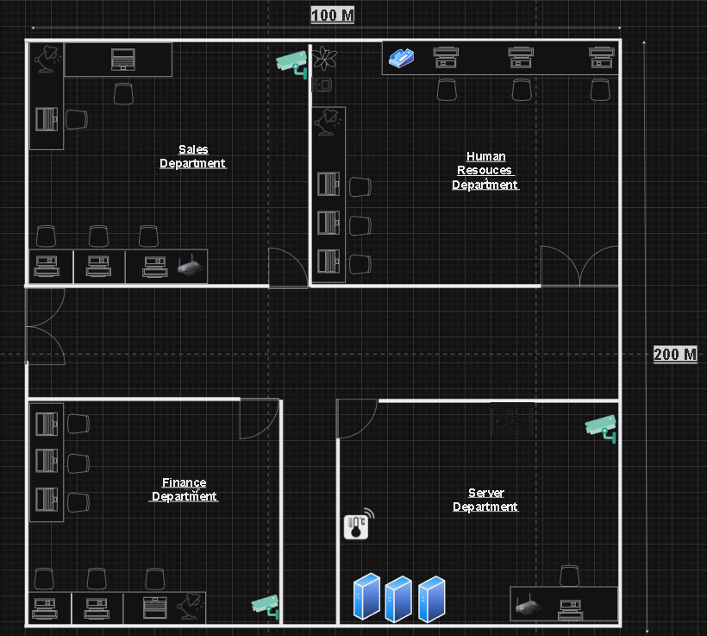
Figure 4.1 Malacca Floor Plan

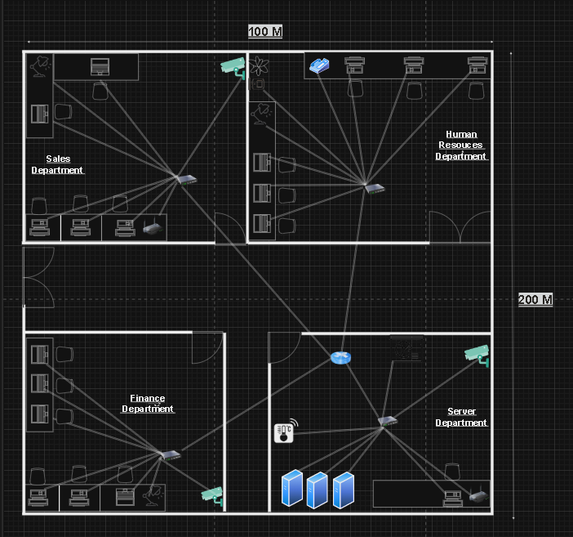
Figure 4.2 Network Diagram for Malacca
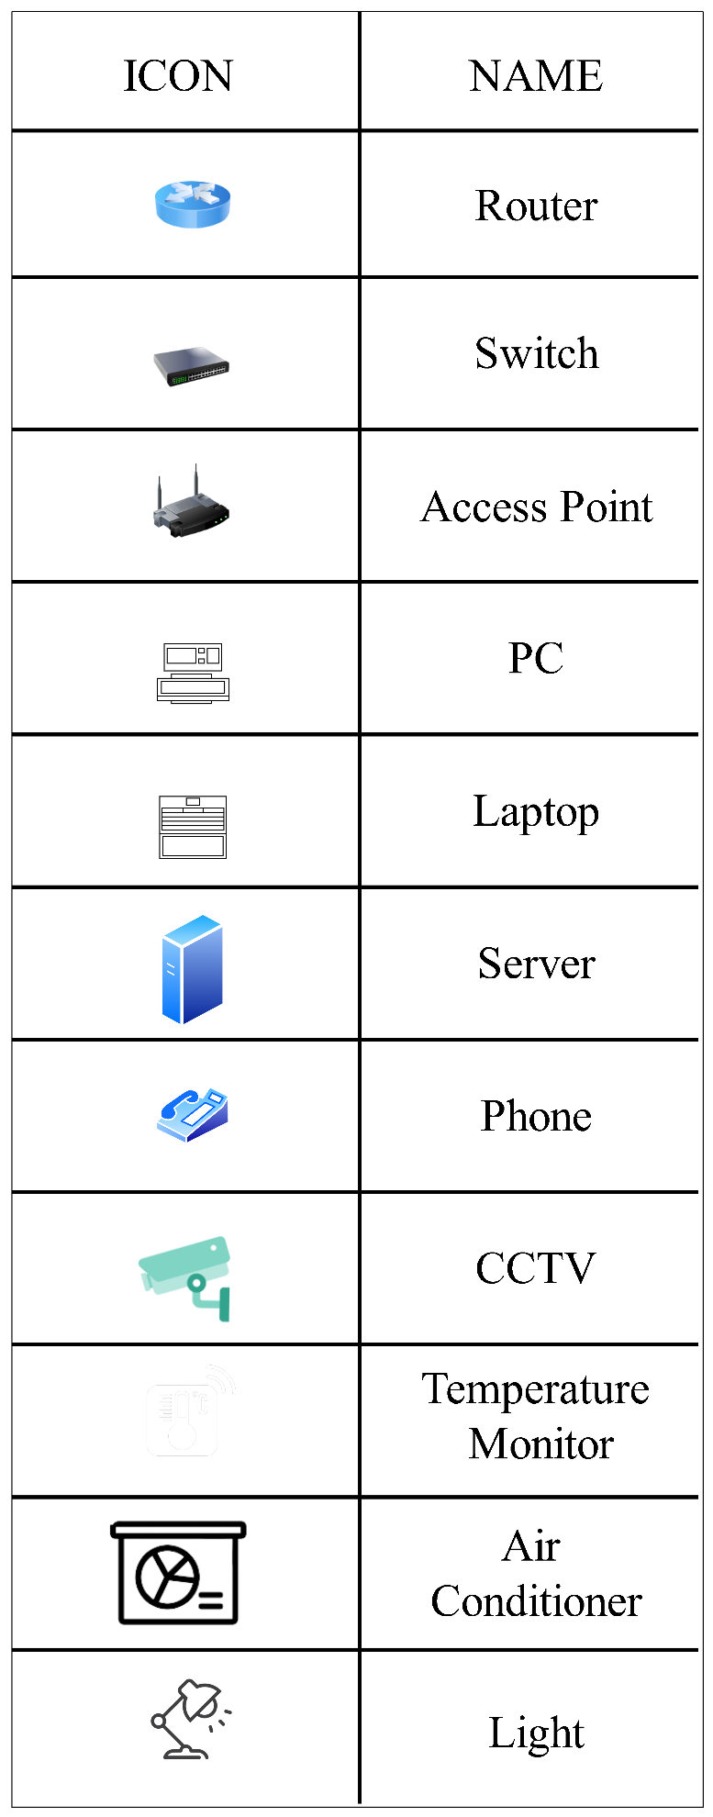
The floor plan for MapleTech branch in Malacca is equipped with 4 departments which are Sales Department, Human Resources Department, Finance Department and Server Department. The sales department oversees bringing in money for the company by offering its goods or services to clients. Human Resources Department is the most significant resource of the company. Its goal is to recruit, train, inspire, and keep a motivated and talented staff. The management of the company's financial assets, preservation of its financial stability, and enhancement of profitability fall within the purview of the Finance Department. The Server Department holds the security and maintenance such as servers and networks within the company. The length of MapleTech Malacca branch office is 200m and the width is 100m, these measurements are specifically done to adequate each departments size and ensures there is extra room for further expansion of the branch.

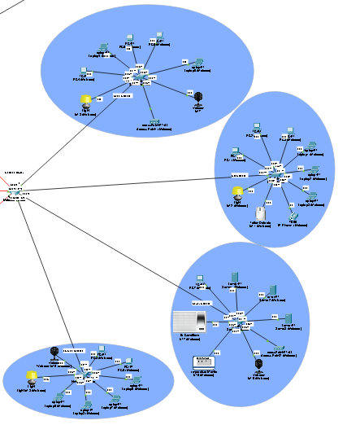
Figure 4.3 Network topology design for Malacca Branch
Figure 4.4 Network Topology for all 4 offices
With the use of Cisco Packet Tracer, I created a network topology from the floor plan above to show the 4 departments that are in the Malacca branch office of MapleTech. Each department is equipped with a switch that connects to a dedicated router. The type of router used is the PT Router. For the switches, Switch-PT is used as it accommodates all the cables needed and has sufficient ports for all the hosts. The end devices that are used are PCs, laptops, server, phone, and access points. The usage of Internet of Things (IoT) devices such as light, temperature monitor, air conditioner and webcams. From the network topology, we can mimic real-world scenarios and make sure that the network can manage the anticipated traffic.

4.2 JUSTIFICATION OF THE TOPOLOGY

4.2.1 STAR TOPOLOGY AND EXTENDED STAR TOPLOGY

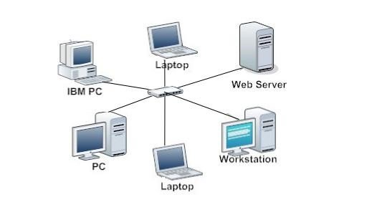
Figure 4.5 Star Topology

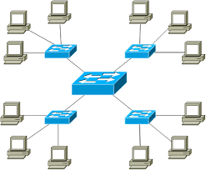
Figure 4.6 Extended Star Topology

The two most common LAN topologies are the star topology and extended star topology. Every end device connected to a centralised point such as hubs or switches is known as a star topology. When all the end devices are connected to a hub or switch, the network arrangement is displayed as a star. (What Is Star Topology? Definition and Explanation - Javatpoint, n.d.). Extended star topology is an extra networking device that is connected to the primary networking device. The network is controlled by a single centralized networking device that is formed by a mesh of switches that are linked to one another. (Bhardwaj, 2021)

Aspect | Star Topology | Extended Star Topology
Structure | Has a single level of structure. | Has more than one or multiple levels of structure.
Centralised Point | A single switch or hub acts as the central device. | Multiple switches or hubs that are connected to a more advanced central device.
Redundancy | No inherent redundancy | Has redundant central devices for increased network reliability
Complexity | Easy and simple to form and manage. | More complex and hard to manage.
Cost | Low cost | Cost can be higher due to additional devices.

By comparing the characteristics of Star Topology and Extended Star Topology, I have concluded and decided that Star Topology suits the most for the Malacca Branch of MapleTech.

4.3 IP ADDRESING SCHEME

4.3.1 IP ADDRESSING TABLE

Device | Interface | Network Address | IP Address | Usable Address Range | Broadcast Address | Default Gateway
Malacca Router | Fa1/0 | 192.168.40.64/28 | 192.168.40.65/28 | 192.168.40.65 - 192.168.40.78 | 192.168.40.79 | N/A
 | Fa0/0 | 192.168.40.80/28 | 192.168.40.81/28 | 192.168.40.81 - 192.168.40.94 | 192.168.40.95 | N/A
 | Fa2/0 | 192.168.40.96/28 | 192.168.40.97/28 | 192.168.40.97 - 192.168.40.110 | 192.168.40.111 | N/A
 | Fa3/0 | 192.168.40.112/28 | 192.168.40.113/28 | 192.168.40.113 - 192.168.40.126 | 192.168.40.127 | N/A
 | Se5/0 | 192.168.40.208/24 | 192.168.40.210/24 | 192.168.40.210 - 192.168.40.212 | 192.168.40.213 | N/A
 | Se6/0 | 192.168.40.216/24 | 192.168.40.217/24 | 192.168.40.217 - 192.168.40.219 | 192.168.40.220 | N/A
 | Se7/0 | 192.168.40.212/24 | 192.168.40.213/24 | 192.168.40.213 - 192.168.40.215 | 192.168.40.216 | N/A
Human Resources Switch | Fa0/1 | 192.168.40.64/28 | 192.168.40.66/28 | N/A | N/A | 192.168.40.65
Sales Switch | Fa0/1 | 192.168.40.80/28 | 192.168.40.82/28 | N/A | N/A | 192.168.40.81
Server Switch | Fa0/1 | 192.168.40.96/28 | 192.168.40.98/28 | N/A | N/A | 192.168.40.97
Finance Switch | Fa0/1 | 192.168.40.112/28 | 192.168.40.114/28 | N/A | N/A | 192.168.40.113
PC1  (Malacca) |  | 192.168.40.64/28 | 192.168.40.67/28 | N/A | N/A | 192.168.40.65
PC2 (Malacca) |  | 192.168.40.64/28 | 192.168.40.68/28 | N/A | N/A | 192.168.40.65
PC3 (Malacca) |  | 192.168.40.64/28 | 192.168.40.69/28 | N/A | N/A | 192.168.40.65
Laptop1 (Malacca) |  | 192.168.40.64/28 | 192.168.40.70/28 | N/A | N/A | 192.168.40.65
Laptop2 (Malacca) |  | 192.168.40.64/28 | 192.168.40.71/28 | N/A | N/A | 192.168.40.65
Laptop3 (Malacca) |  | 192.168.40.64/28 | 192.168.40.72/28 | N/A | N/A | 192.168.40.65
Motion Detector IoT1 (Malacca) |  | 192.168.40.64/28 | 192.168.40.73/28 | N/A | N/A | 192.168.40.65
Light IoT2 (Malacca) |  | 192.168.40.64/28 | 192.168.40.74/28 | N/A | N/A | 192.168.40.65
PC4 (Malacca) |  | 192.168.40.80/28 | 192.168.40.83/28 | N/A | N/A | 192.168.40.81
PC5 (Malacca) |  | 192.168.40.80/28 | 192.168.40.84/28 | N/A | N/A | 192.168.40.81
PC6 (Malacca) |  | 192.168.40.80/28 | 192.168.40.85/28 | N/A | N/A | 192.168.40.81
Laptop4 (Malacca) |  | 192.168.40.80/28 | 192.168.40.86/28 | N/A | N/A | 192.168.40.81
Laptop5 (Malacca) |  | 192.168.40.80/28 | 192.168.40.87/28 | N/A | N/A | 192.168.40.81
Light IoT3 (Malacca) |  | 192.168.40.80/28 | 192.168.40.88/28 | N/A | N/A | 192.168.40.81
Webcam IoT4 (Malacca) |  | 192.168.40.80/28 | 192.168.40.89/28 | N/A | N/A | 192.168.40.81
PC7 (Malacca) |  | 192.168.40.96/28 | 192.168.40.99/28 | N/A | N/A | 192.168.40.97
Server1 (Malacca) |  | 192.168.40.96/28 | 192.168.40.100/28 | N/A | N/A | 192.168.40.97
Server2 (Malacca) |  | 192.168.40.96/28 | 192.168.40.101/28 | N/A | N/A | 192.168.40.97
Server3 (Malacca) |  | 192.168.40.96/28 | 192.168.40.102/28 | N/A | N/A | 192.168.40.97
Webcam IoT5 (Malacca) |  | 192.168.40.96/28 | 192.168.40.104/28 | N/A | N/A | 192.168.40.97
Temperature Monitor IoT6 (Malacca) |  | 192.168.40.96/28 | 192.168.40.105/28 | N/A | N/A | 192.168.40.97
PC8 (Malacca) |  | 192.168.40.112/28 | 192.168.40.115/28 | N/A | N/A | 192.168.40.113
PC9 (Malacca) |  | 192.168.40.112/28 | 192.168.40.116/28 | N/A | N/A | 192.168.40.113
Laptop6 (Malacca) |  | 192.168.40.112/28 | 192.168.40.117/28 | N/A | N/A | 192.168.40.113
Laptop7 (Malacca) |  | 192.168.40.112/28 | 192.168.40.118/28 | N/A | N/A | 192.168.40.113
Laptop8 (Malacca) |  | 192.168.40.112/28 | 192.168.40.119/28 | N/A | N/A | 192.168.40.113
Laptop9 (Malacca) |  | 192.168.40.112/28 | 192.168.40.120/28 | N/A | N/A | 192.168.40.113
Light IoT8 (Malacca) |  | 192.168.40.112/28 | 192.168.40.121/28 | N/A | N/A | 192.168.40.113
Webcam IoT9 (Malacca) |  | 192.168.40.112/28 | 192.168.40.122/28 | N/A | N/A | 192.168.40.113

4.3.2 JUSTIFICATIONS OF THE IP ADDRESSING AND SUBNETTING SCHEME
To begin, a Class C IP address was used for network, which was 192.168.40.0. For the Malacca branch of MapleTech the first IP address used was 192.168.40.65 and the last IP address used was 192.168.40.216. The range of network was divided into 4 departments which are the Sales Department, Human Resources Department, Finance Department and Server Department. To take advantage of the IP addresses that are accessible, Variable Length Subnet Masking (VLSM) was utilized to create subnets of different sizes based on the number of hosts in each department.
A /28 prefix length was used to create 16 subnets, each with 14 usable IP addresses for each of the departments in MapleTech Malacca branch. This was done to effectively utilize IP addresses and to consider prospective branch development.

5.0 JUSTIFICATION OF THE CONFIGURATION TECHNIQUES

5.1 CONFIGURATION FOR ROUTER AND SWTICHES

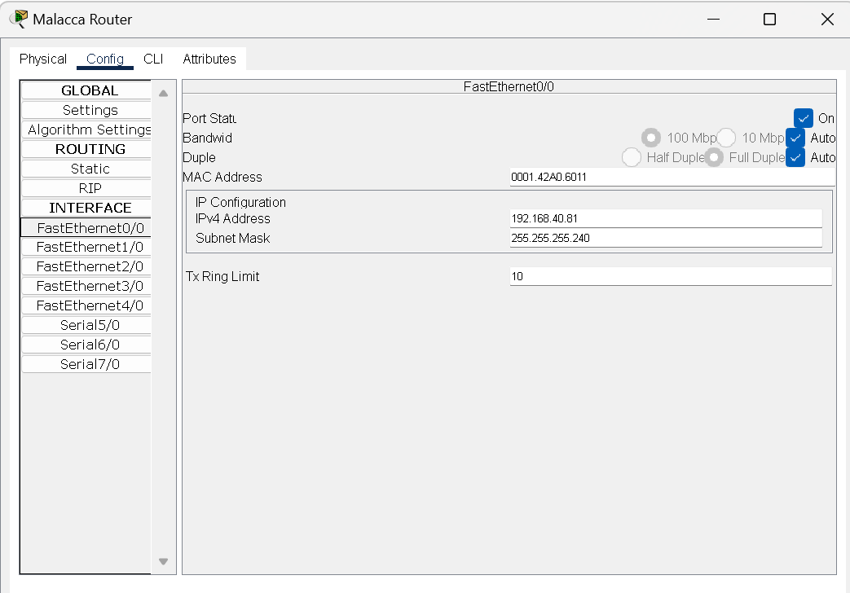
Figure 4.7 IP configuration for Router
IP configuration for the routers and switches is done by static routing. It is done by inserting the IP address from the IP addressing table created into the respectable interface ports.

5.2 IP ROUTING (RIP)

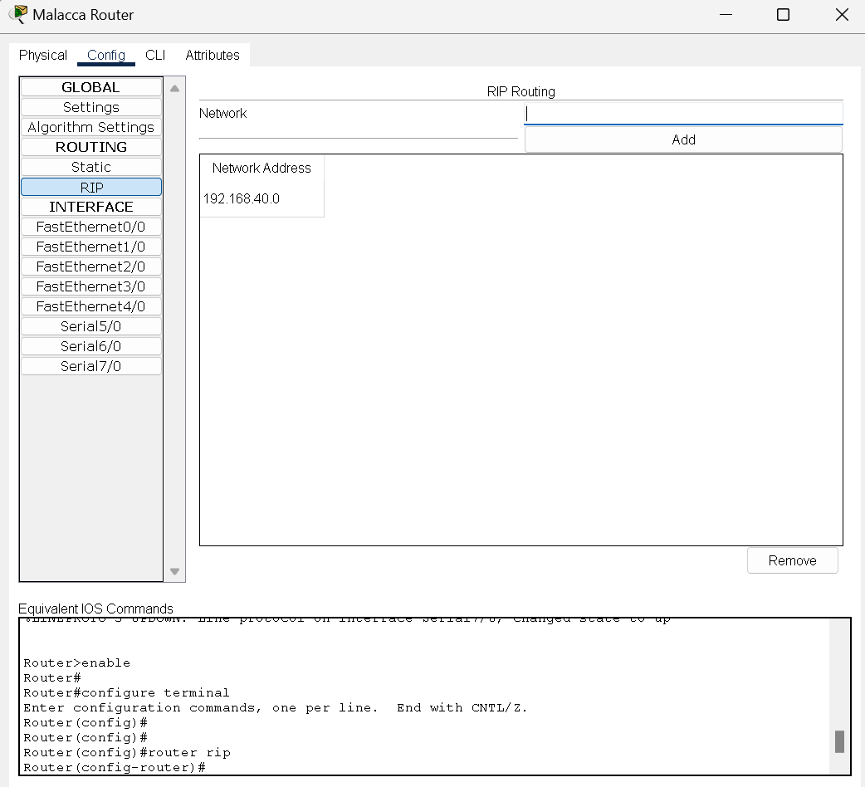
Figure 4.9 IP routing for Router
IP routing is the process of transmitting IP packets via a router or gateway from a specific network to another network. In the figure above, I’m showcasing the IP route configuration of offsite router. By using the RIP Routing the network address 192.168.40.0 is added the “Network Address” column. The RIP Routing in other routers as well such as KL, Malacca, Ipoh, and Penang was done accordingly. By doing so the network will be able to ping with other devices from another network.

5.2 STATIC CONFIGURATION FOR END DEVICES AND IOT DEVICES

Static routing is a protocol that needs you to manually assign IP addresses to each end device and IoT devices on a network.

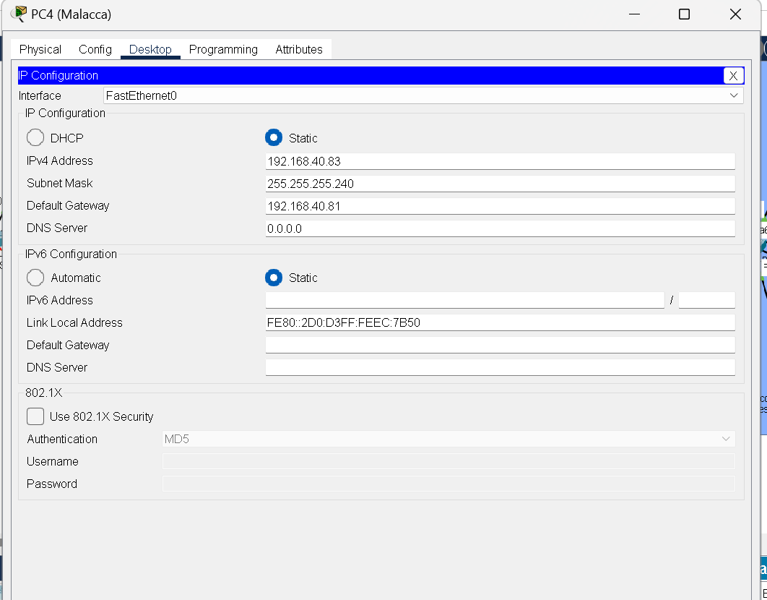
Figure 4.10 IP Configuration for end devices

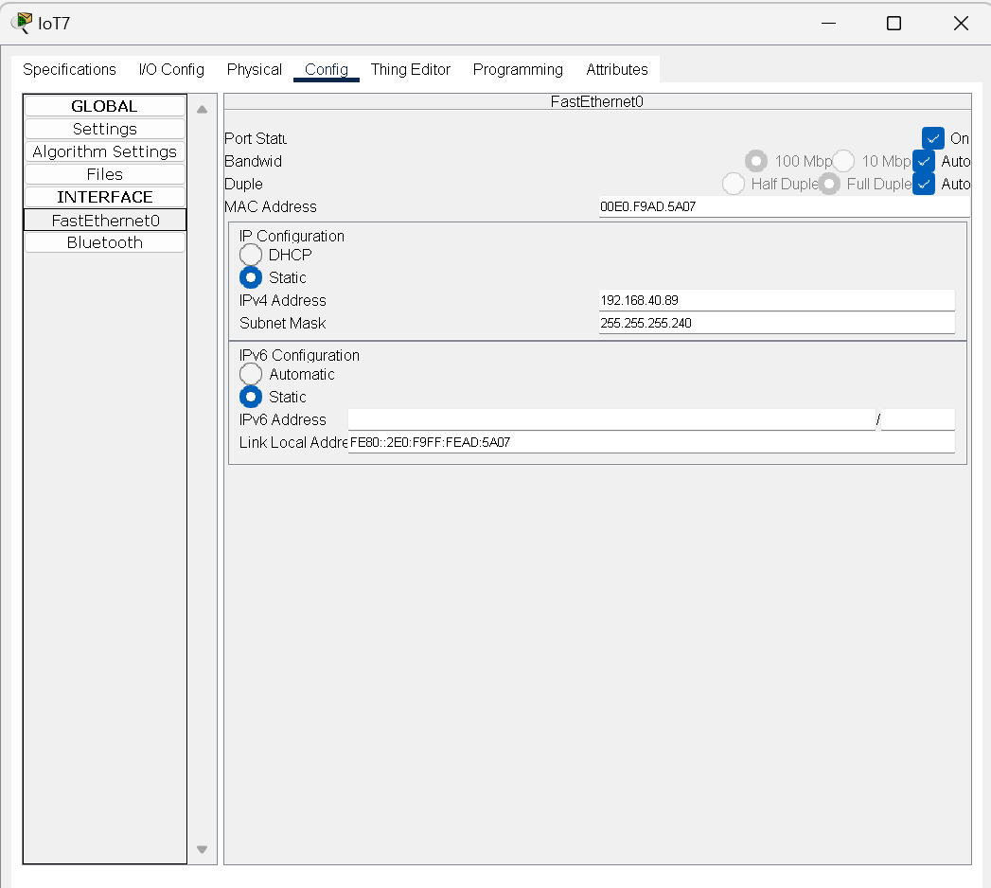
Figure 2.11 IP configuration for IoT Devices

6.0 CONCLUSION
In conclusion, it was a difficult but satisfying undertaking to develop and build an IP addressing system for the Maple Tech branches network using Star Topology. Each branch's IP addresses were efficiently assigned under the subnetting technique, which also enabled good communication between the branches.

Despite the challenge, the experience was rewarding since it gave participants practical knowledge of network configuration and design. Additionally, it provided a chance to put theoretical knowledge to use in real-world situations and see how networks function. The IP addressing and subnetting utilised in the MapleTech network have shown to be successful and efficient in establishing communication between the branches. This task is a great learning opportunity, and we know that the information and abilities we have acquired will be helpful in our future work.

7.0 REFERENCES
Advantages and Disadvantages of Star Topology. https://www.geeksforgeeks.org/advantages-and-disadvantages-of-star-topology/

Bhardwaj, R. (2021, December 17). Extended Star Network Topology » Network Interview. Network Interview. https://networkinterview.com/extended-star-network-topology/

Computer Hope (2023, May 03). Star Topology. https://www.computerhope.com/jargon/s/startopo.htm

Margaret Rouse (2023, June 28). Star Topology. https://www.techopedia.com/definition/13335/star-topology

Wevolver. (2023, January 12). A comprehensive guide to understanding star topology in computer networks. https://www.wevolver.com/article/a-comprehensive-guide-to-understanding-star-topology-in-computer-networks

What is Star Topology? Definition and Explanation - javatpoint. www.javatpoint.com. https://www.javatpoint.com/what-is-star-topology

What is a star network? https://www.techtarget.com/searchnetworking/definition/star-network

https://www.techtarget.com/searchnetworking/definition/star-network
https://www.geeksforgeeks.org/advantages-and-disadvantages-of-star-topology/

